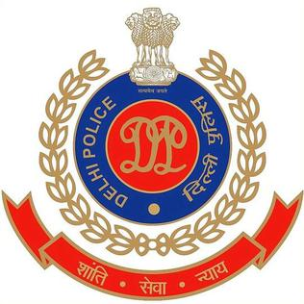

PRESS RELEASE
DELHI POLICE

07.03.2022

SPUWAC

- Celebrating the International Women’s Day
- M/S Hero MotoCorp Ltd provided 215 scooters to Delhi Police, under Corporate Social Responsibility Scheme, for deployment in areas prone to crime against women

Introduction

The theme for International Women’s Day, 8 March 2022 is “Gender equality today for a sustainable tomorrow”.

The SPUWAC or the Special Police Unit for Women and Children is a special body of Delhi Police, which aims to safeguard the rights of women and children in the Capital.

On 07.03.2022, SPUWAC has organized a special program at Central Park, Connaught Place, Delhi to celebrate the International Women’s Day. M/S Hero MotoCorp Ltd, under their CSR programme ‘Hamari Pari’ provided 215 scooters to Delhi Police, under their Corporate Social Responsibility Scheme, for deployment in areas prone to crime against women.

Sh. Rakesh Asthana, Commissioner of Police, Delhi was the Chief Guest for the occasion. The celebration also included a dance and drama performance by Dr. Sreya’s, Advance Healthcare foundation

The event was witnessed by a host of senior Delhi Police Officers and staff from all ranks. Media person, both from the print and electronic mediums, graced the occasion.

The safety of women and vulnerable sections is a top priority for the Delhi Police. Delhi Police has set its target to raise the participation of women police personnel to one-fourth of the total strength of Delhi Police by 2025.

(DR. JOY TIRKEY) IPS
DY COMMISSIONER OF POLICE
SPUWAC, DELHI

